## BJS

# BHARATIYA JAIN SANGHATANA’S

# Arts, Science & Commerce College

A Project Report On

“ **CompNex E-commerce Website** ”

# Submitted to

# SAVITRIBAI PHULE UNIVERSITY

# In partial fulfilment of the Requirement of

Bachelor of Business Administration (Computer Application)

(Semester – III)

Submitted By

**Mr. Shailesh S. Mourya**

Under the guidance of

**Prof. Rohini Shewale**

### DEPARTMENT OF B.B.A(C.A)

### CERTIFICATE

**This is to certify that Mr. Shailesh S. Mourya of class B.B.A (C.A) (Semester III) have Completed the Project Work on**

#### “CompNex E-commerce Website for Computer Components” Under my guidance & supervision in a satisfactory manner for the Practical fulfilment of BBA(CA) Sem (III) examination for the academic year 2025-2026.

**Dr. B.B. Landge Dr.Sanjay Gaikwad**

**(Incharge) (Principal )**

#### Project Guide Internal Examiner External Examiner Prof.

**Date: Place:**

**INDEX**

|  |  |  |
| --- | --- | --- |
| **Sr. No** | **Name** | **Page** |
| **1)** | **Abstract:**  **A concise Summary of Project** | **01** |
| **2)** | **Introduction**  **2.1) Background of Project**  **2.2) Problem Statement**  **2.3) Objective and Goals**  **2.4)Scope and Limitations** | **02** |
| **3)** | **System Analysis**  **3.1) Existing System and their limitation**  **3.2) Project Prespective and Features**  **3.3) Requirement Analysis**  **( Functional , Performance , Security )** | **03** |
| **4)** | **System Design**  **4.1) Design Constraints**  **4.2) Flow Chart**  **4.3) User Interfaces ( Design Screens)** | **09** |
| **5)** | **Implementation Details**  **5.1) Software and Hardware Specification**  **5.2) Screenshots of Working System and**  **Reports** | **11** |

|  |  |  |
| --- | --- | --- |
| **6)** | **Testing**  **6.1) Input, Expected Output**  **6.2) Screens With Validations**  **6.3)Error / Success Message Window** | **21** |
| **7)** | **Conclusion and Recommendation** | **22** |
| **8)** | **Future Scope** |  |
| **9)** | **Bibliography and References** |  |
| **10)** | **Abbreviation** |  |

## Project Report

## CompNex Store - Online Computer Hardware

## E-commerce Platform (Prototype)

##  

1. **Abstract**

         

The CompNex Store E-commerce Prototype is designed to offer a straightforward, detailed online shopping experience for anyone looking to buy high-performance computer hardware. The system organizes a wide range of technical products - like the RTX 5090 and AMD Ryzen 9 9000 - making it easy to browse, compare, and explore each item's detailed specifications.

Dedicated product pages give users a closer look at the features that matter most, while simulated shopping functions like 'Add to Cart' and user login/sign-up let visitors see how the checkout process would work.

With this prototype, users can quickly compare complex PC components, making it simpler to find and choose the right parts for their custom builds. The easy access to product details and the simulated buying experience help save time and make the process more convenient overall.

1

      **2. INTRODUCTION**

**2.1) Background of Project**

CompNex Store started out with a pretty clear aim: build an online shop that's all about top-tier computer hardware - stuff like cutting-edge graphics cards, CPUs, and fast RAM. No distractions, just the serious gear.

Most online stores feel overwhelming and too broad, so if you're trying to compare tricky specs or track down exactly the right part for a custom build, it turns into a headache. Finding real numbers, side-by-side, just isn't easy.

This project is just a front-end demo for now - basically, it looks and acts like a real store, but there's no working database and nothing happening behind the scenes except for some basic pop-up alerts. The whole point was to show what a proper store for hardcore PC people could look like if it were done right.

**2.2) Problem Statement**

* Weak product details: Usually, all the key specs you need to double-check compatibility just aren't there.
* Messy categories: PC parts are thrown in with totally unrelated computer gadgets, which makes searching a pain.
* No real help with compatibility : Most sites won't tell you if that motherboard will actually work with your RAM or CPU.
* Light on the technical side: There's no performance data or side-by-side comparisons, so you're left guessing how parts stack up.
* Pain to use on your phone: Product pages tend to get clunky or broken when you're shopping on mobile.

**2.3) Objective And Goals**

**Objective:**  
Build a slick, inviting site (think of it as a high-end shop window) for selling ultra-powerful computer hardware, where buyers can actually see what they're getting

**Goals:**

* **Design the Look:** Every page needs to feel sharp and up-to-date. Go for a dark background with red highlights, so it stands out - home page, product listings, sign-up, the works.
* **Show Off the Parts:** Make sure all the specs are front and center. If a CPU has "48 Cores / 96 Threads," show it right next to the product. No confusion, straight-up details.
* **Make Things Click:** Set up the sign-in and sign-up screens, and let people hit "Buy" on anything - even if it's just for show right now.

**2.4) Scope & Limitation**

**Scope:**

* Front-end development using HTML5, CSS3, and JavaScript
* Create a responsive design that works on all devices
* Build a product catalog with search and filter features
* Set up user registration and login
* Include a shopping cart and checkout process
* Develop a basic order management system

**Limitation :**

* Payment gateway integration is for simulation purposes only (real transactions aren't processed)
* Includes a basic inventory management system
* Stock levels don't update in real time
* Works only with pre-set product categories
* The first version won't have advanced recommendation features

      **ACKNOWLEDGEMENT** 

**We express our profuse thanks to our Guide Mrs. Rohini Shewale. We wish to express our thanks to respected teachers and all teaching staff who have been a constant source of encouragement and assistance.**

**Last but not least, we are also grateful to College Library, Computer Lab and workshop facilities made available by our college.**

**I also express my thanks to all my friends & specially my relative who helped me directly or indirectly in preparation of this project.**

**Mr.Shivratna Dipak Savargave**

**Mr. Pandurang Siddheshwar Manale**

**2**

###       Existing System 

* The homepage will give a brief introduction to the Movie Recommendation System, its mission, and the services it offers
* **User Engagement:** Existing movie recommendation systems such as Netflix, Amazon Prime, and Hulu engage users by providing personalized recommendations based on viewing history and preferences.
* **Data-Driven Suggestions:** These systems leverage data science algorithms to suggest movies that are likely to match user interests, improving the user experience.
* **Ease of Access:** Users can easily browse through movies based on genre, trending status, or ratings, without much effort.

**3**

###  ADVANTAGES AND DRAWBACKS 

**Advantages of system :**

#### User Friendly :

The system has got much simplified screen which makes the system fast enhances quick and accurate data.

#### Easy to Handle :

This system is easy to handle, this mainly due to simple functionality.

#### Reliability :

The reliability of the proposed system will be high due to the above stated reasons. The reason for the increased reliability of the system is that now there would be proper storage of information.

### Drawback of system :

1. **Lack of immediate retrievals:**
2. **Lack of immediate information storage:**
3. **Lack of prompt updating.**

**4**

###   Fact Finding Techniques 

**To understand the existing system's functioning and user pain points, the following fact-finding techniques were used:**

1. **Surveys/Questionnaires:** Sent out to users who are actively involved in online movie streaming platforms, gathering feedback about their experiences.
2. **Interviews:** Conducted interviews with users to identify challenges they face when searching for movies and content suggestions.
3. **Competitor Analysis:** A deep dive into the working mechanisms of existing systems like Netflix, Hulu, and Amazon Prime to analyze their strengths and weaknesses in content recommendation.

**5**

 **PROPOSED SYSTEM** 

**Hardware & Software Specification**

**Hardware Requirement :**

• Processor : Intel(R) CoreDuo 1.30 GHz

• Primary memory (RAM) :800MB

• Secondary memory (Hard Disk) : 4 GB Onwards

• Printer : HP DeskJet D2568 other

**Software Requirement :**

• Operating System : Microsoft Windows 10 Pro Version 22H2

• Front-End : Visual Basic 6.0

**Proposed System :**

**The proposed system will offer:**

**Personalized Movie Recommendations:** Based on user preferences, viewing history, and trending content.

**Search Functionality**: Users will be able to search for movies by title, genre, or actor.

**Trending Movies:** A section for showcasing popular movies of the week.

**User-Friendly Interface:** A clean, responsive design that adapts to both mobile and desktop devices.

**6**

**Objective of Proposed System:**

1. To create a movie recommendation system that provides personalized suggestions to users based on their preferences and viewing patterns.
2. To integrate data from popular movie platforms and provide an easy-to-use interface for exploring movies.
3. To enhance the user experience by simplifying the process of finding new and interesting content.

7

 

 **Scope of Proposed System :**

This application is made in such a way that it will be useful for people

to save their time and watching the movie.

**The scope of specification includes the following situations :**

1. **Genres:** The system will cover multiple movie genres such as Action, Comedy, Drama, Romance, Thriller, and more.
2. **API Integration:** The system will integrate with APIs like TMDb to fetch real-time movie data.
3. **Multi-Platform:** Accessible on both desktop and mobile devices, ensuring broader accessibility.

**8**

## 

##  System Analysis 

## ERD Diagram :

**User**

**Log**

**in**

**Movie**

M

**contains**

**Has**

**Movie Recommendation System**

M

1

1

**9**

❖ **DFD :**

**Login Request**

**Authentication**

**Admin**

**User**

**Login successful Successful**

**Select Filter**

**Movie Suggest Successfull Suggest Movie**

**10**

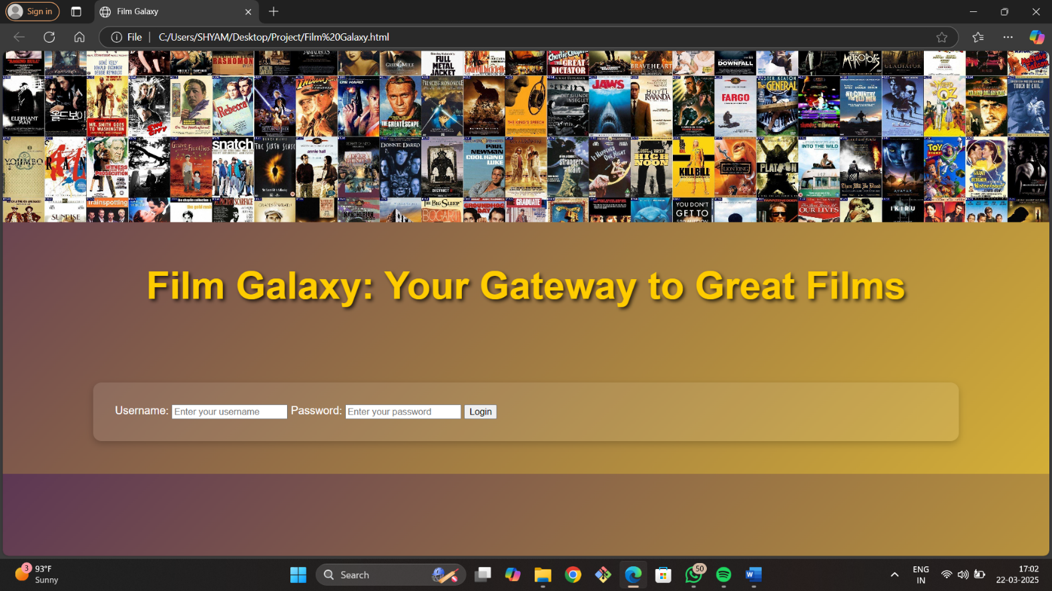

**11**

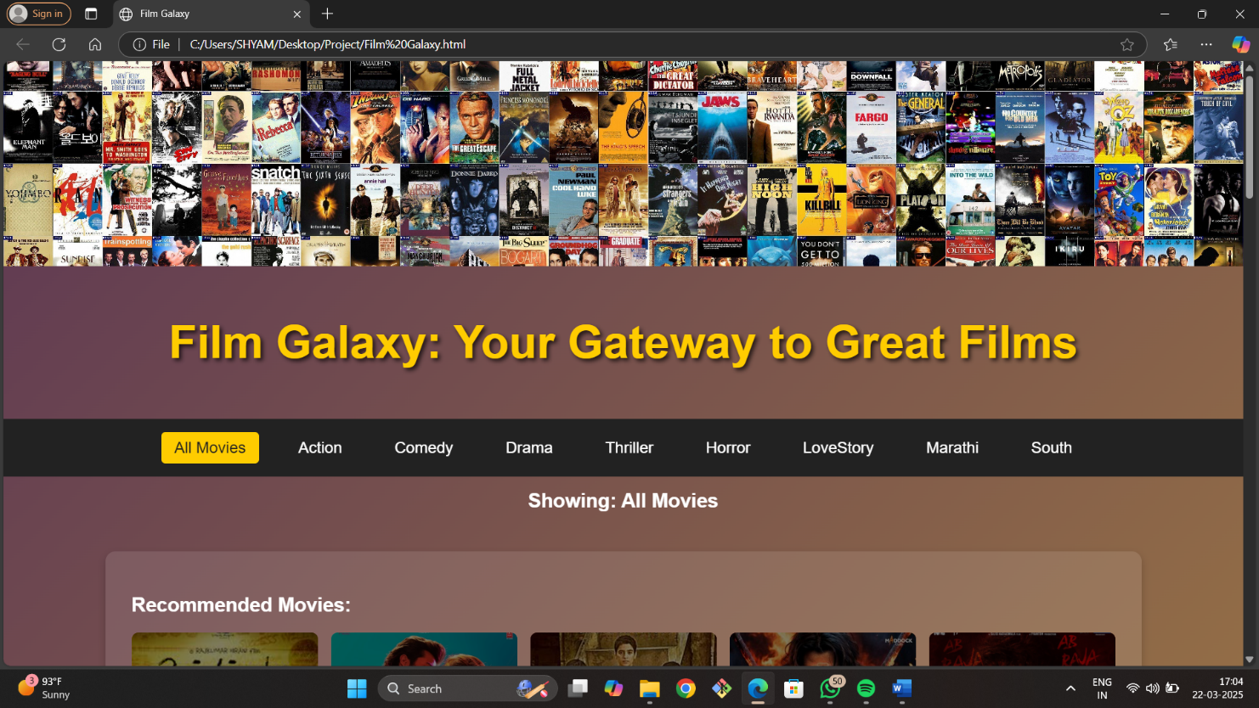

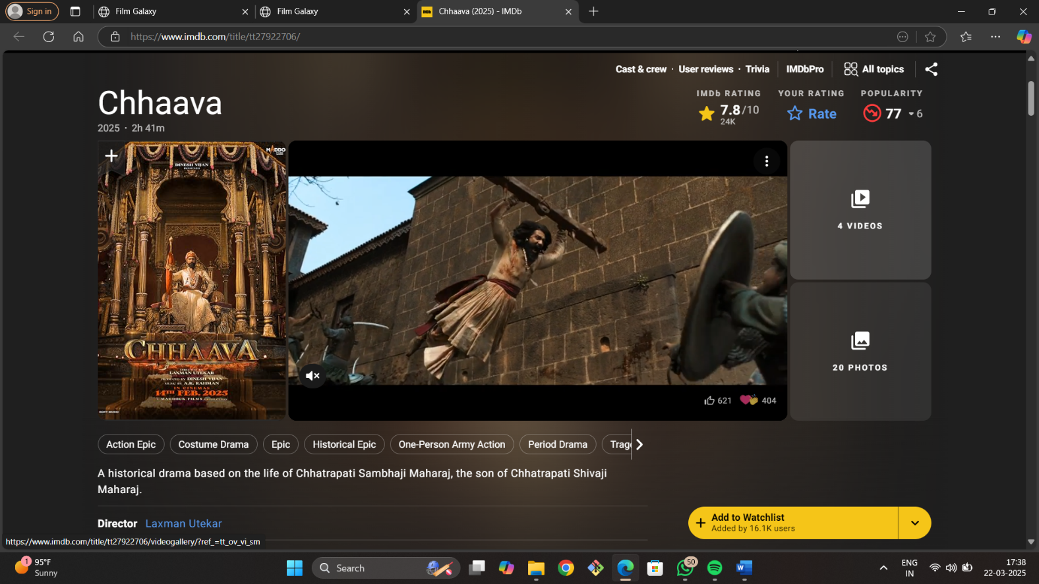

**12**

### 

### 

### 13

### 

### 

### 

### 14

### 

### 

### 15

### 

### 

### 16

### 

### 

### 17

### 

### 

### 18

### 

### 

### 19

### 

### 

### 20

### Future Enhancement :

1. User Registration & Authentication

2. Movie Posters & Details

3. Search & Filter Options

4. Watchlist & Favorites

5. User Reviews & Ratings

**21**

###         Bibliography :

**Books Referred:-**

* + - * + VB Black Book
        + Web Technology Book
        + Software Engineering Book
        + Node-Js Book
        + Operating System

[**www.google.com**](http://www.google.com)

**22**

THANK YOU

**23**